Comprehensive Concrete Strength Analysis: From Exploratory Scatterplots to ANOVA Validation

By: Cleric Josh C. Najarro
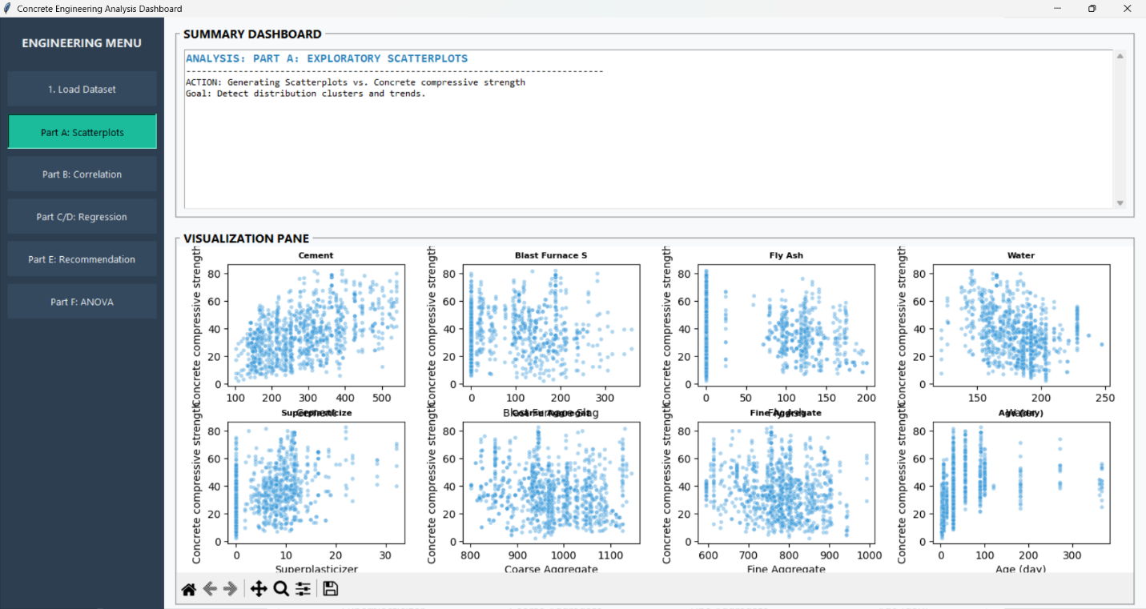
Part A: Scatterplots

Part B: Correlation

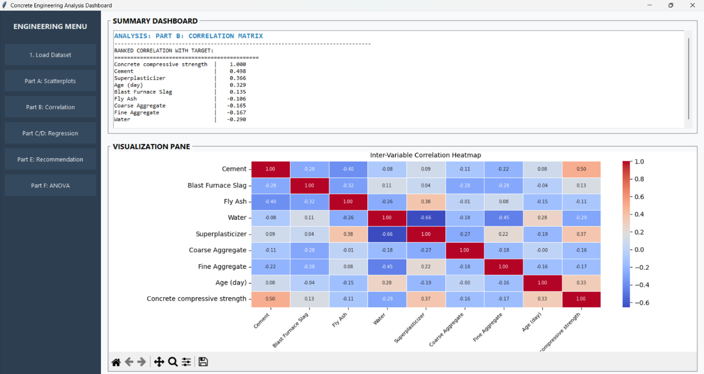

Part C/D: Regression
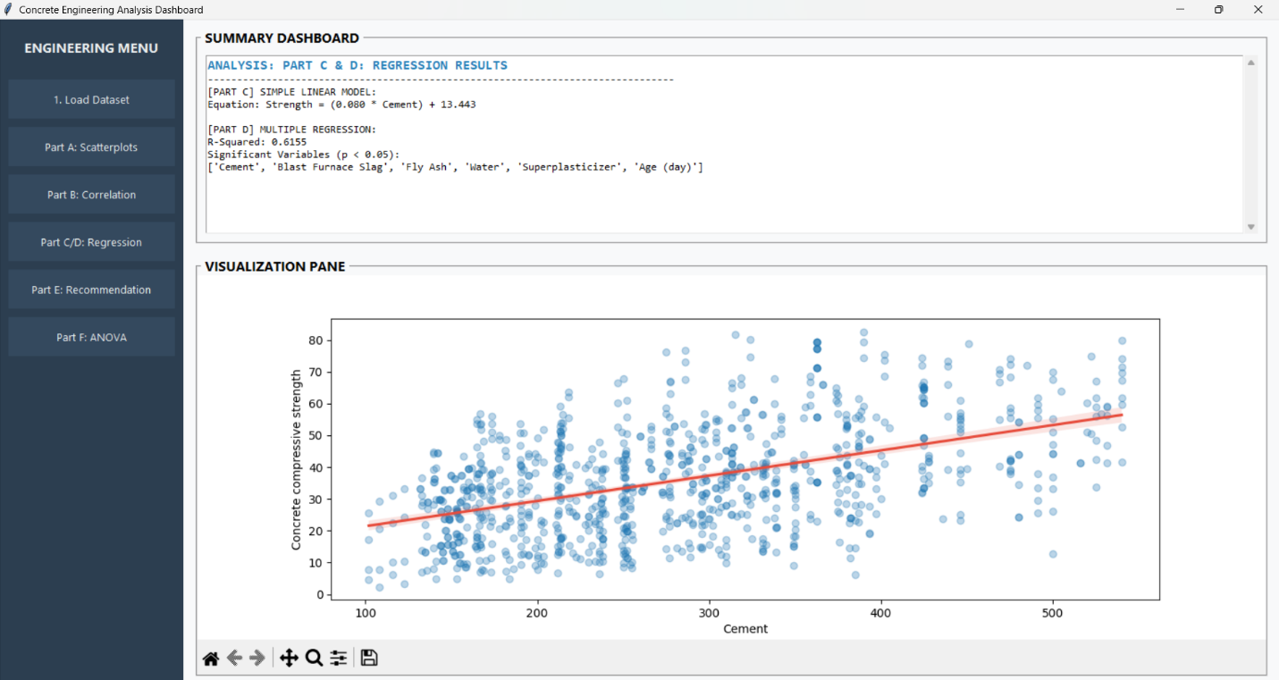
Part E: Recommendation
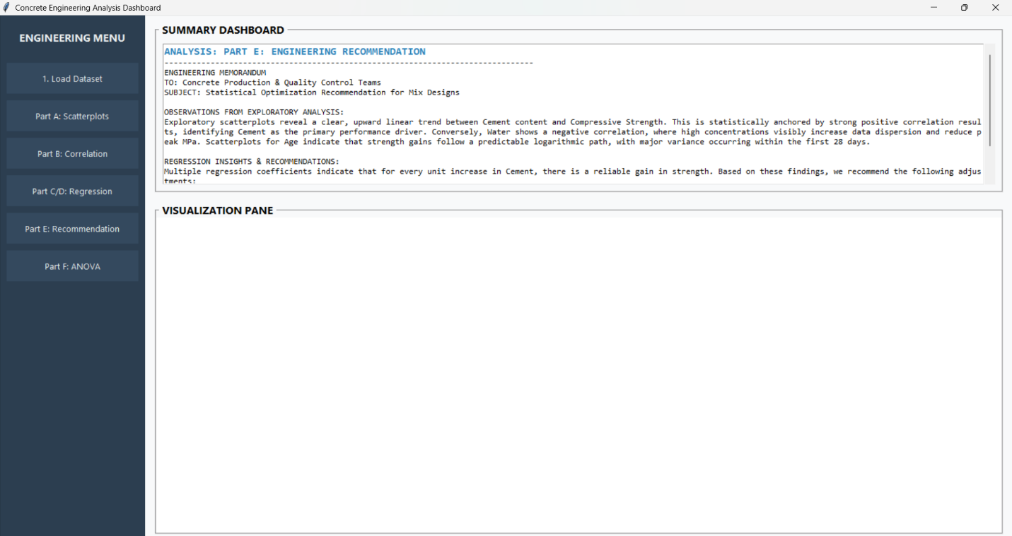
ENGINEERING MEMORANDUM
TO: Concrete Production & Quality Control Teams
SUBJECT: Statistical Optimization Recommendation for Mix Designs

OBSERVATIONS FROM EXPLORATORY ANALYSIS:
Exploratory scatterplots reveal a clear, upward linear trend between Cement content and Compressive Strength. This is statistically anchored by strong positive correlation results, identifying Cement as the primary performance driver. Conversely, Water shows a negative correlation, where high concentrations visibly increase data dispersion and reduce peak MPa. Scatterplots for Age indicate that strength gains follow a predictable logarithmic path, with major variance occurring within the first 28 days.

REGRESSION INSIGHTS & RECOMMENDATIONS:
Multiple regression coefficients indicate that for every unit increase in Cement, there is a reliable gain in strength. Based on these findings, we recommend the following adjustments:
- CEMENT & WATER: Optimize the water-cement ratio by lowering Water volume and utilizing Superplasticizer additives to maintain workability while maximizing the binding efficiency.
- SLAG & FLY ASH: Both Blast Furnace Slag and Fly Ash contribute positively to long-term structural integrity; they should be maintained as supplementary binders to reduce cost without losing durability.
- CURING TIME: Regression data confirms that Age is a non-negotiable factor. We recommend enforcing a minimum 28-day curing standard to ensure hydration processes reach the target statistical threshold for structural safety.

Part F: Anova
